Clinical Trials Object Data System (CTODS) Lab Viewer 1.0

caXchange – ScenPro, Inc.

End User Guide

DOCUMENT CHANGE HISTORY
Version Number | Date | Contributor | Description
1.0 | 1/09/2008 | Michael Holck | Initial Draft
1.1 | 2/08/2008 | Michael Holck | Update Content
1.2 | 2/11/2008 | David Dorman | Updated screenshots and content with the latest version
1.3 | 2/11/2008 | Michael Holck | Added additional dependencies
1.4 | 2/18/2008 | Michael Holck | Added hotlinks from other applications
1.5 | 2/26/2008 | Michael Holck | Updated with John Speakman’s edits
1.6 | 11/25/2008 | Anupama Sharma | Update Content


Updated February 26, 2008

Contact Information
Contacts and Support
NCICB Application Support | http://ncicb.nci.nih.gov/NCICB/support  Telephone: 301-451-4384  Toll free: 888-478-4423

LISTSERV Facilities Pertinent to software teams
LISTSERV | URL | Name
CABIG_CTMS-L | https://list.nih.gov/archives/cabig_ctms-l.html | caBIG Clinical Trials Management System List
CABIG_CTMS_COND_SIG | https://list.nih.gov/archives/cabig_ctms_cond_sig.html | CTMS Study Conduct SIG List

TABLE OF CONTENTS
1. Background/Summary 1
2. Introduction 2
2.1 Overview 2
2.2 Dependencies 2
2.3 Security 2
3. Application Operation Steps 3
3.1 Login 3
3.2 Search for trial(s) 5
3.2.1 Successful Search Operation 5
3.2.2 Unsuccessful Search Operation 8
3.3 Load results to CDMS 9
3.4 View Patient in caAERS 11
3.5 Log Out 13
3.6 Hot Linking from caAERS 14
3.7 Hot Linking from THE PATIENT STUDY CALENDAR (PSC) 16

Background/Summary
The Clinical Trials Object Data System (CTODS) Lab Viewer is a web based application that allows users to view laboratory activities that have been retrieved from clinical laboratory systems (e.g., by caXchange) and stored in the CTODS database. Users will be allowed to search Study, Patient and laboratory activity records. The Study search displays the When the search results are displayed, numeric results that are outside the high and low reference ranges of the lab tests will be highlighted to alert the user. This visual alert/trigger will allow the user to focus in and act on those specific lab test results.
Additionally, the CTODS Lab Viewer will allow users to send lab data via caXchange to caBIG™-compatible Clinical Data Management System (CDMS) applications. The CTODS Lab Viewer interface allows the user to select which labs should be loaded into the CDMS.

Introduction

Overview
This user guide identifies and describes the general features and functionality as provided and displayed by CTODS Lab Viewer version 1.0.
The CTODS Lab Viewer documentation can be accessed at: https://gforge.nci.nih.gov/plugins/scmcvs/cvsweb.php/caxchange/?cvsroot=caxchange

Dependencies
The assumptions and dependencies to support the use of CTODS Lab Viewer by a user include:
- The CTODS is available for use on an authorized system/network
- Current system security protocols are in place and operational
- The user has access and authorization to use CTODS Lab Viewer
- If sending labs to a caBIG(tm)-compatible CDMS is required, the CDMS is installed and accessible, and the caXchange hub has been installed and configured properly

Security
CTODS Lab Viewer accesses, displays, and brokers sensitive individually identifiable patient health information. It is the user’s responsibility to ensure that CTODS Lab Viewer is used appropriately. Please note:
- Patient information should be viewed by authorized personnel only
- Patient information must not be released in any form to anyone not directly authorized to view and use the information
- Users must log out and close the browser at the conclusion of the session
- Users must not provide others with their unique user ID and password

Application Operation Steps

Login
- Insert and execute the CTODS Lab Viewer URL using a compatible web browser.
- The ‘CCTS Single Sign On’ applications access page will display.
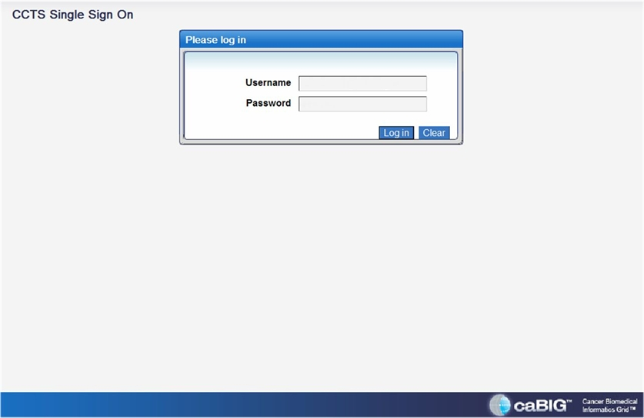
- Enter your ‘Username’ and ‘Password’ in the fields of the same name.
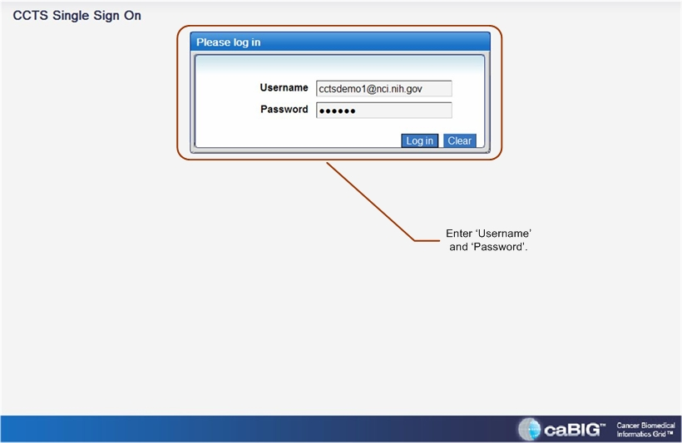
- Select the ‘LOGIN’ button to access CTODS Lab Viewer.
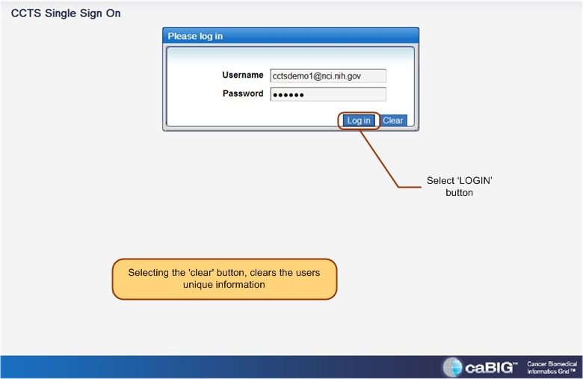
- The CTODS Lab Viewer ‘Home’ page with ‘Welcome’ will display.
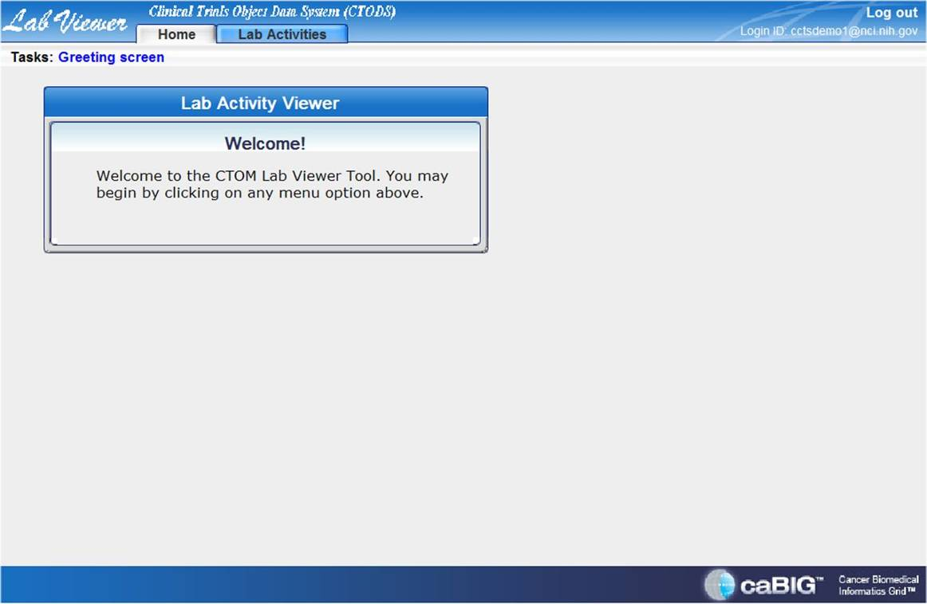

Search for trial(s)

Successful Search Operation
- Select the ‘Lab Activities’ tab.
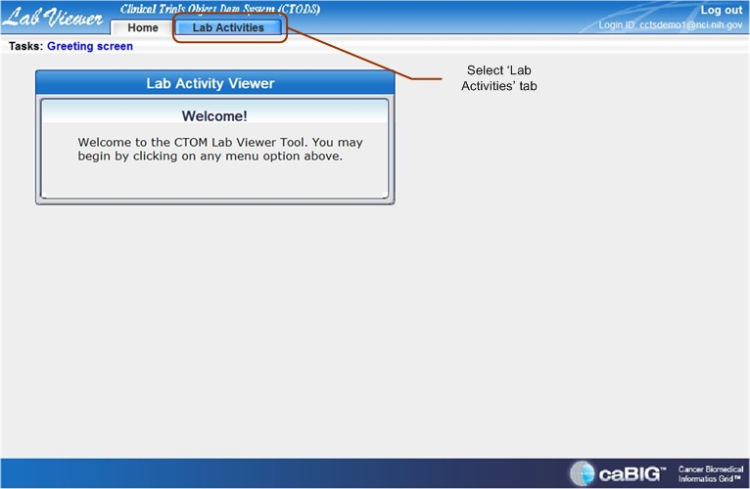
- The ‘Lab Activities’ search page will display.
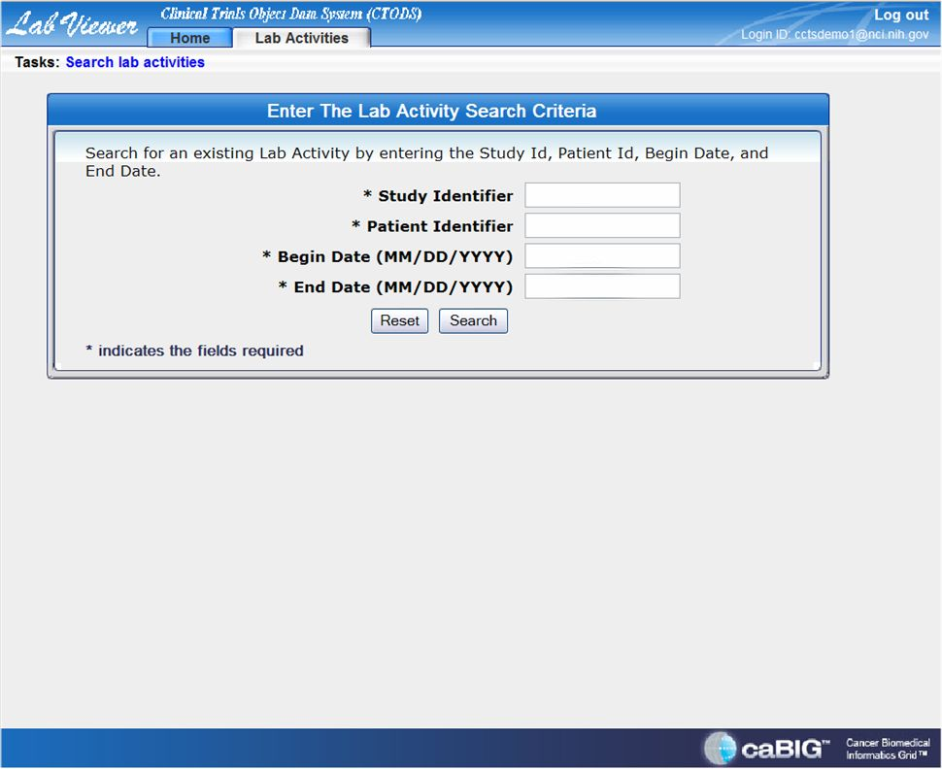
- Enter the desired variables in the search criteria fields (i.e. ‘Study Identifier,’ ‘Patient Identifier,’ ‘Begin Date,’ and ‘End Date’).
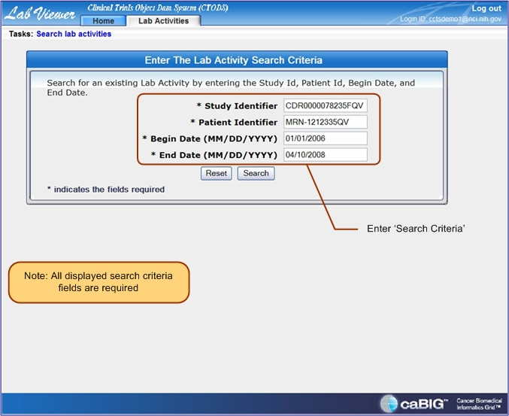
- Select the ‘Search’ button.
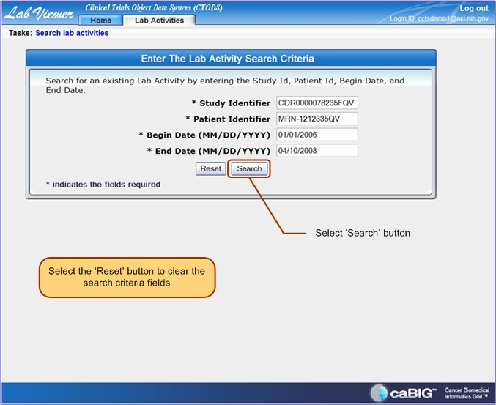
5a. The search results page will display (multiple results).
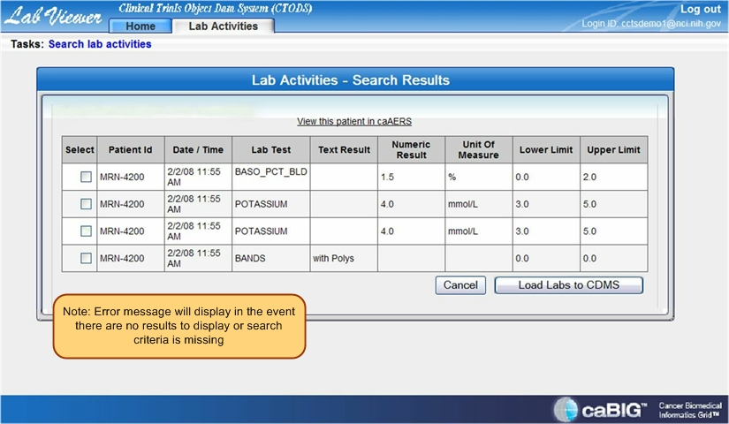
5b. The search results page will display (multiple and ‘out of range’ results).
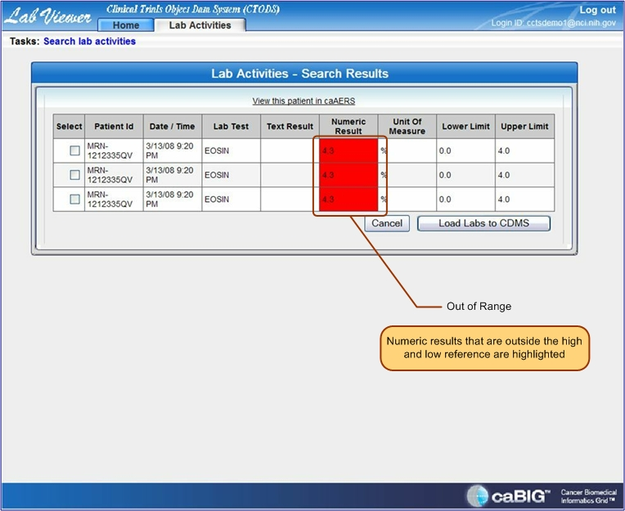

Unsuccessful Search Operation
An error message will display if the entered search criteria are incorrect/missing or there are no results to display.
1a. An ‘ERROR’ message will display when the ‘Search’ button is selected and the search criteria are incorrect/missing.
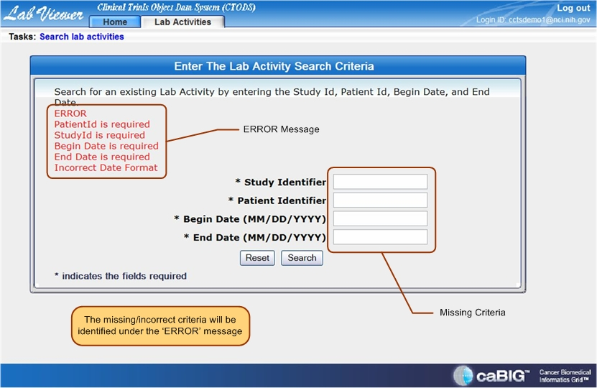
1b. An ‘ERROR’ message will display when the ‘Search’ button is selected and there are no search results to display.
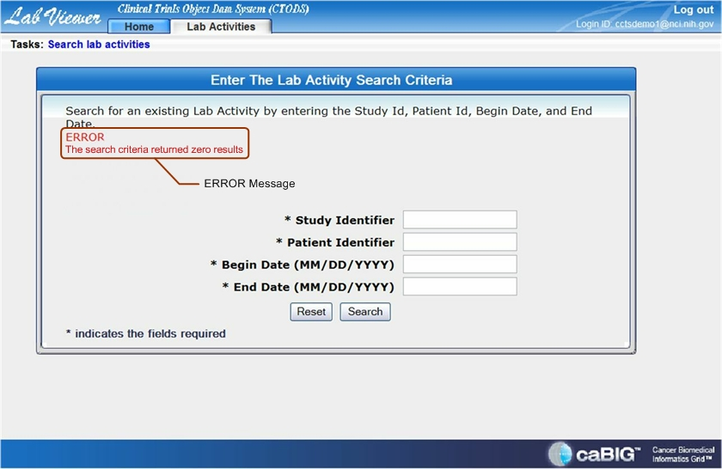

Load results to CDMS
- ‘Check’ the desired search results to export.
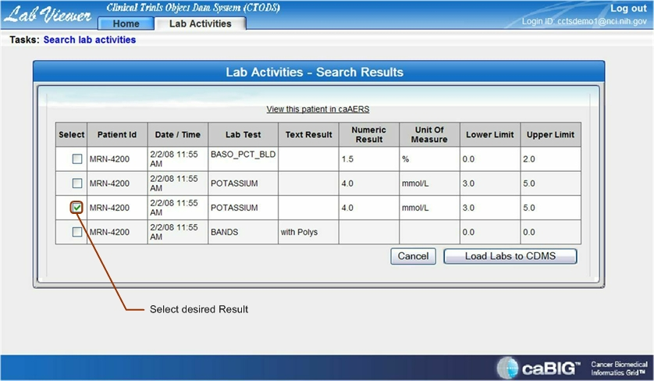
- Select the ‘Load Labs to CDMS’ button.’
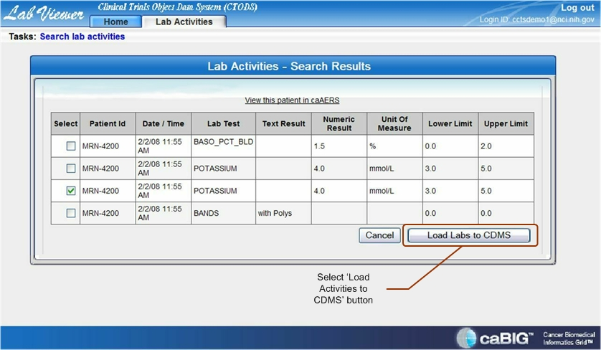
3a. A ‘Submitted to CDMS Successfully’ message displays on the search results page.
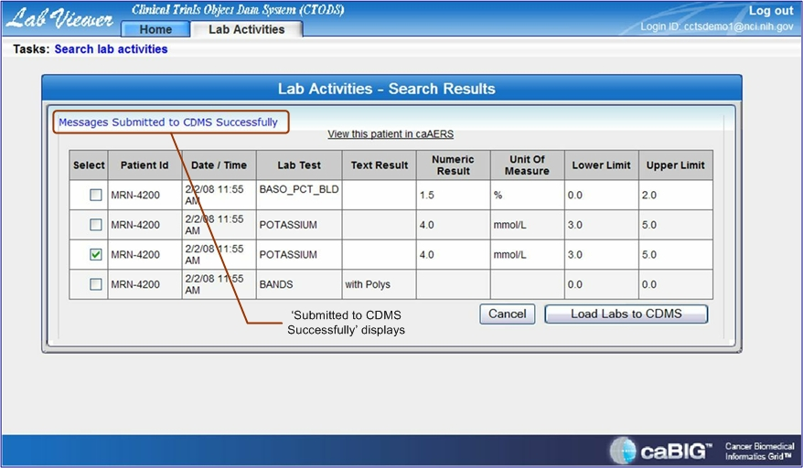
3b. An ‘Error in Submitting Messages to CDMS’ message displays on the search results page when submission was unsuccessful.
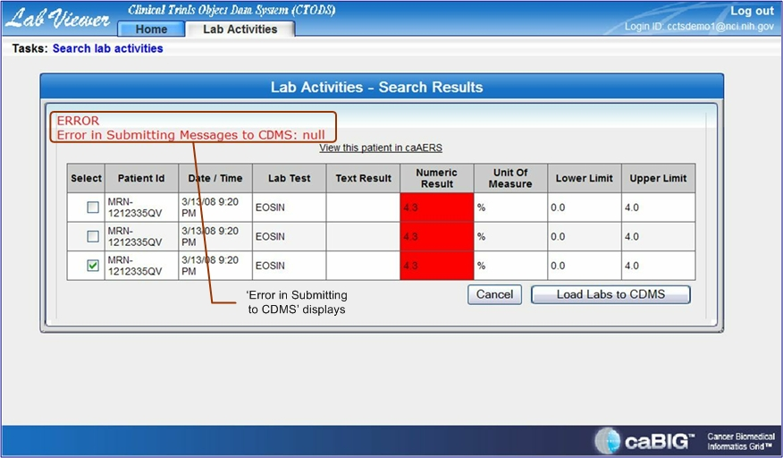

View Patient in caAERS
- Select the ‘View this patient in caAERS’ hyperlink to view addition patient data.
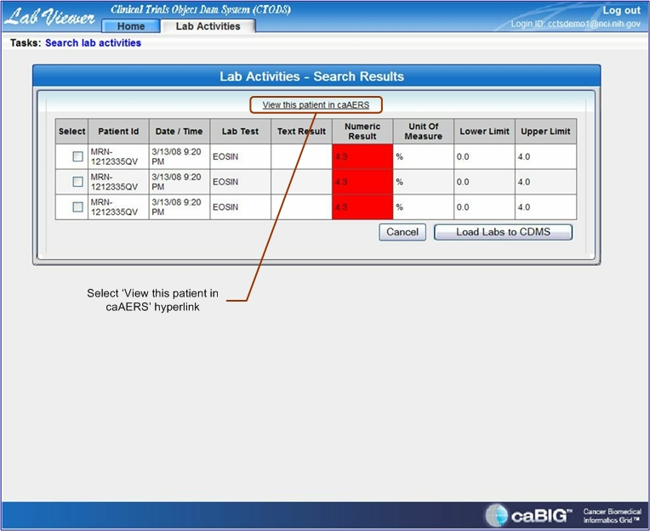
2a. Patient data is available to view.
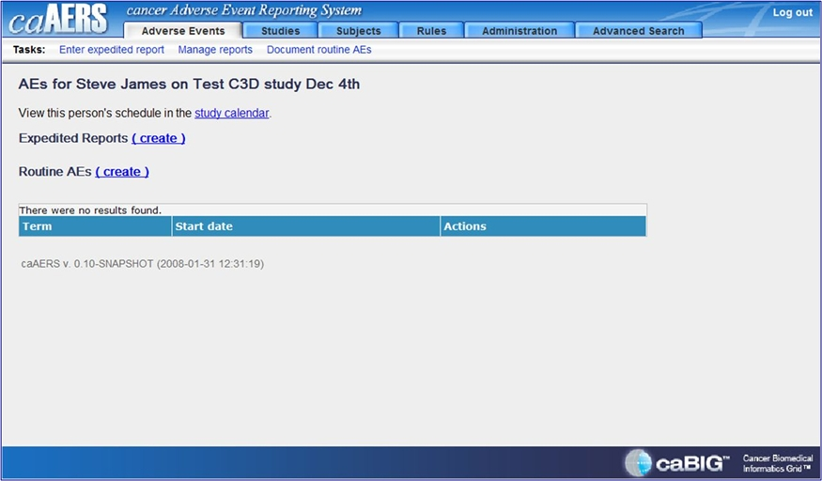
2a. Patient data is not available to view.
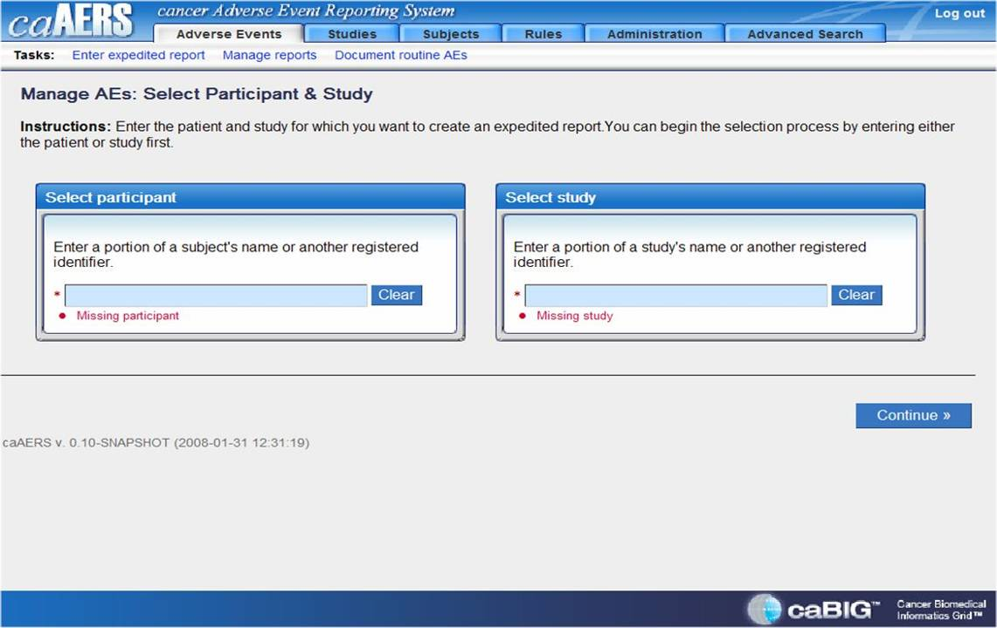

Log Out
- Select the ‘Log Out’ hyperlink to close page.
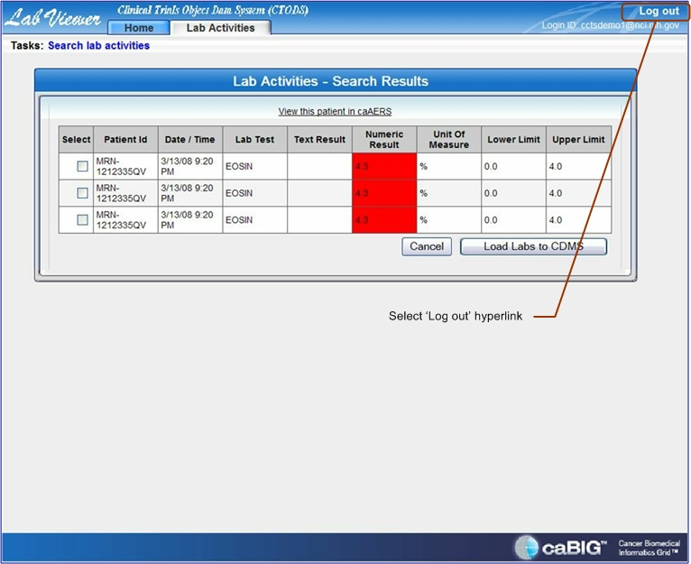
- Close web browser application to terminate CTODS Lab Viewer session.

Hot Linking from caAERS
- When viewing a participant’s labs in caAERS there will be a hot link available to link directly to Lab Viewer.
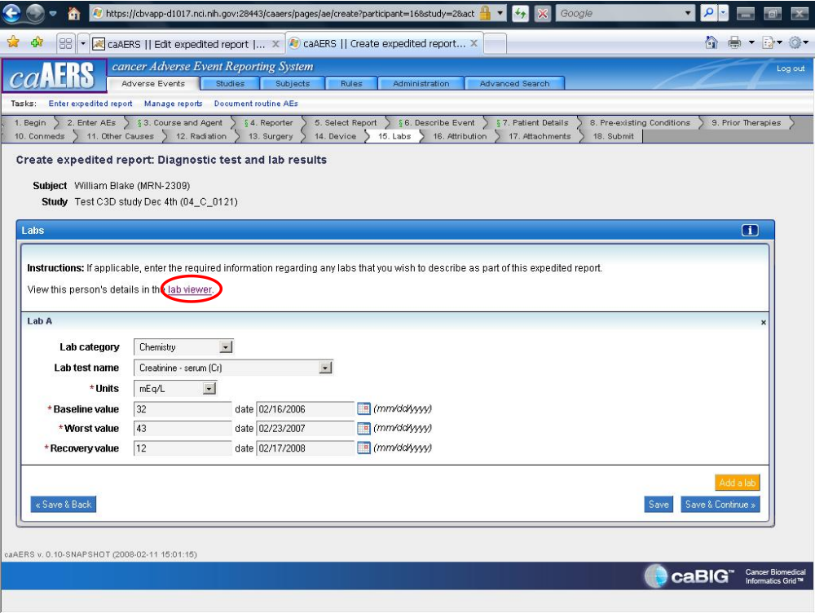
- Selecting this link will open a new browser window to Lab Viewer with the study and patient information pre-populated. The date range will still need to be entered.
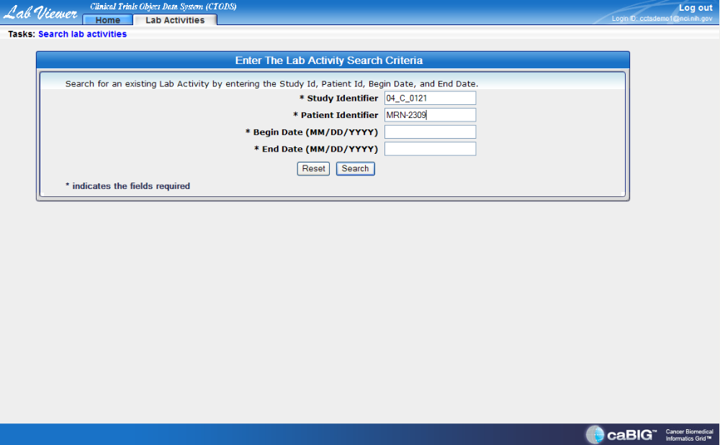

Hot Linking from THE PATIENT STUDY CALENDAR (PSC)
- When viewing a patient’s calendar in PSC there will be a hot link available to link directly to Lab Viewer.
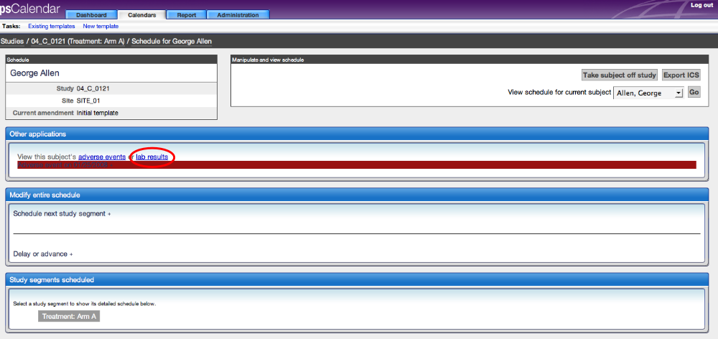
- Selecting this link will open a new browser window to Lab Viewer with the study and patient information pre-populated. The date range will still need to be entered.

